REDOKSS CARR LLC

The company was founded in September 2019 and began its dynamic development with the production of bathtubs, shower trays, washbasins and hyghienic panels for these products. These products are made only by hand from high quality imported materials.
Developing the business, the company improved the existing product protfolio and gained experience in new technologies for working with fiberglass and polyurethane foam products and began to engage in professional repair, restoration of fiberglass parts and hulls of water transport, from minor damage to total restoration of holes and general restoration of the acrylic parts of water transport . The companys specialists have experience in the repair and restoration of dozens of vessels and small-sized boats, jet skis and catamarans.

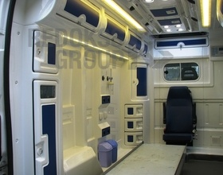
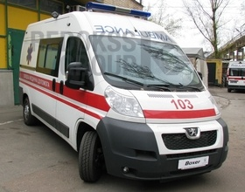
The company is also engaged in the production of interior lining for specialized ambulances. The company’s production facilities currently have the ability to produce cladding for specialized vehicles - ambulances based on the following vehicles: Volkswagen T4, Mercedes Sprinter, Ford Transit, Volkswagen Crafter, Pegeot Boxer, Renault Master, Opel Vivaro, Fiat Ducato.

The specialists of our company were previously trained and took part in the work of Astromal (Poland) in the production of interior cladding for buses and trucks, namely: Scania, Volvo, Mercedes and Renault.

Also, with the participation of the founders of the company, we participated in the projects concerning interior and exterior cladding for urban trams, which run along the streets of Vinnitsa to this day. We also produced, and worked on the cladding for locomotives.

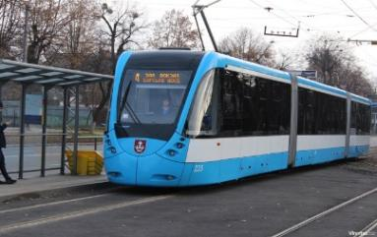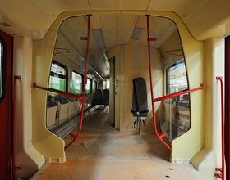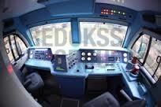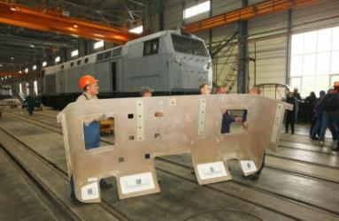

At the moment, our company cooperates with the company PAT NVO Praktika producing parts made of fiberglass and polyurethane for armored vehicles.

Today, the company manufactures the following products:
- Fiberglass sanitary ware and furniture (completely handmade).
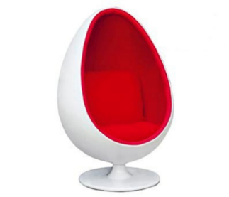
At the moment, the company produces under the brand name REDOKSS SAN high-quality bathtubs, panels and frames, shower trays, washbasins and many other products (ball chairs, beach chairs, bar stools, etc.). If we compare products on the national market, then in the price category we are at a level below the average, but in quality we are significantly ahead of national manufacturers and such foreign manufacturers as KOLO, CERZANIT and in most RAVAK parameters.

Retail prices for our sanitary ware (in euros):
No. | Description | Item No. | Price, EUR  washbasins | Washbasin photo
1 | Washbasin 60 * 50 * 13 (suitable for washing machine) | APR 001-14 | 100.00 | 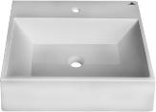
2 | Washbasin 60 * 50 * 13 (suitable for washing machine) | APR 002-14 | 100.00 | 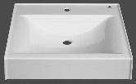
3 | Washbasin 60 * 60 * 8.5 (suitable for washing machine) | APR 013-17 | 96.74 | 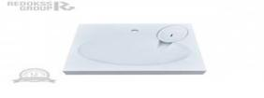
6 | Washbasin 56 * 53 * 13 | APR 003-14 | 100.00 | 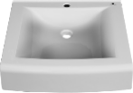
7 | Washbasin 100 * 50 * 8 | APR 004-14 | 151.94 | 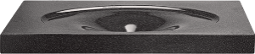  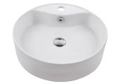
8 | Washbasin 47 * 14 (depth) | APR 005-14 | 136.29
9 | Washbasin 50 * 50 (depth) | APR 006-14 | 151.61 | 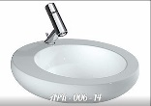
10 | Washbasin 52 * 52.5 (depth) | APR 007-14 | 177.42 | 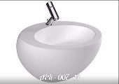
11 | Washbasin 130 * 49 | APR 008-14 | 177.42
  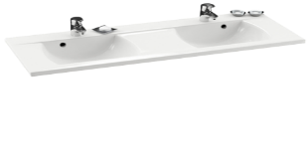
12 | Washbasin 45 * 25 | APR 009-14 | 74.19 | 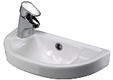
13 | Washbasin 70 * 55 * 20 | APR 010-14 | 136.29 | 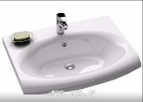  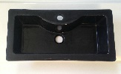  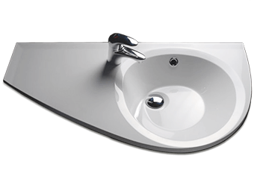
14 | Washbasin 60 * 30 * 15 | APR 011-15 | 88.71
15 | Washbasin 85 * 45 | APR 012-15 | 116.13
16 | Siphon for washbasins on s / m |  | 9.03

Products:  baths | Price, EUR  bath | Price, EUR  carcass | Price, euro panel | Sidebar | Bath + panel + frame (euro)
Rectangular baths
Ravenna; 1200х700 | 160.97 | 27.42 | 66.61 | 33.87 | 288.87
Margarita 1200x950 | 167.74 | 32-26 | 66...77 | 41:29 | 308.06
Rimini 1300x750 | 162.90 | 30.65 | 66.61 | 35-48 | 295.65
Catanzaro1400x750 | 164.52 | 30.65 | 66...77 | 35-48 | 297.42
Salerno 1500х700 | 164.52 | 28.06 | 66...77 | 33.55 | 292.90
Sassari 1500x750 | 172.58 | 33,23 | 66...77 | 35-48 | 308.06
Siracusa; 1600х700 | 192.58 | 33,23 | 66...77 | 33.87 | 326.45
Pescara; 1700х700 | 207.10 | 33,23 | 66...77 | 33.87 | 340.97
Monza 1700х700 | 239.52 | 33,23 | 69.35 | 33.87 | 375.97
Bergamo; 1700x750 | 205.81 | 33,23 | 66...77 | 35-48 | 341.29
Vicenza1700х750 | 205.81 | 33,23 | 66...77 | 35-48 | 341.29
Latina 1750x800 | 225.16 | 33,23 | 72.58 | 37.74 | 368.71
Forli 1800х800 | 206.45 | 35-48 | 88.71 | 37.74 | 368.39
Trento 1800х900 | 287.10 | 35-48 | 103.23 | 41.94 | 467.74
Novara 1800х900 | 232.26 | 35-48 | 88.71 | 41.94 | 398.39
Bolzano 1900x900 | 319.03 | 37.10 | 98.39 | 30.97 | 485.48
Piacenza 1900x1200 | 458.71 | 45:16 | 98.39 | 55/84 | 657.10
Andria; 2000х900 | 373.87 | 37.10 | 102.10 | 41.94 | 555,00
Udine 2000х1400 | 494.84 | 55/84 | 104.84 | 55/84 | 709.35
Arezzo 2050x900 | 413.55 | 37.10 | 104.84 | 41.94 | 597.42
Ferarra L 1500 | 1 161.29 |  |  |  | 1 161.29
Ferarra XL; 1800 | 1,322.58 |  |  |  | 1,322.58
La Specia; 1200х1200 | 210.97 | 30.65 | 80 65 | x | 322.26
Cesena; 1360х1360 | 225.48 | 33,23 | 94.84 | x | 353.55
Barletta1500х1500 | 250,00 | 37.10 | 106.45 | x | 393.55
Grosetto1700х1700 | 309.68 | 41.94 | 116.13 | x | 467.74
Asymmetric baths
Palermo L / R 1500х700 | 241.94 | 30.65 | 84.84 | x | 357.42
Florence L / R 1500х1000 | 210.97 | 33,23 | 84.84 | x | 329.03
Catania L / R 1600х700 | 251.61 | 30.65 | 88.71 | x | 370.97
Verona L / R 1600x1050 | 240.32 | 37.10 | 88.71 | x | 366.13
Messina L / R 1700х700 | 257.42 | 30.65 | 90.97 | x | 379.03
Modena L / R 1700x1050 | 245.16 | 37.10 | 90.97 | x | 373.23
Parma; L / R 1700x1100 | 258.06 | 37.10 | 94.19 | x | 389.35

Products:  Shower trays | Price, EUR  trays | Price, EUR  frame to trays | Price, euro panels per tray | Price, EUR  trays +  panels +  carcass
Square shower trays
Brenta; 800x800 | 152.42 | x | x | 152.42
Santerno; 900х900 | 174.19 | x | x | 174.19
Sillaro; 800x800x270 | 128.23 | 26.45 | x | 154.68
Montone; 900х900х270 | 162.90 | 26.45 | x | 189.35
Rubicon; 800х1200 | 291.94 | x | x | 291.94
Rubicon M; 900х1100 | 291.94 | x | x | 291.94
Rubicon L 900х1200 | 300.00 | x | x | 300.00
Rubicon XS; 900х1300 | 304.19 | x | x | 304.19
Rubicon XM; 900х1500 | 316.45 | x | x | 316.45
Rubicon XL; 900х1700 | 324.19 | x | x | 324.19
Rubicon XXL; 900х2000 | 370.97 | x | x | 370.97
Rubicon XXXL; 1000х1000 | 291.94 | x | x | 291.94
Semicircular shower trays
Marano 800 | 141.94 | x | x | 141.94
Tenna 800x800x250 | 125.81 | 26.45 | 30.65 | 182.90
Casano 900 | 152.42 | x | x | 152.42
Musone 900х900х270 | 134.19 | 26.45 | 30.65 | 191.29
Tronto 1000x1000x280 | 141.94 | 26.45 | 31.61 | 200.00
Asymmetric shower trays
Carapelle L / R 1200x850 | 153.23 | 26.45 | 30.65 | (210) 32

- Repair and restoration of yacht hulls.
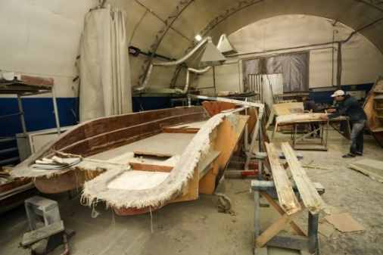
Repair, restoration and reconstruction of fiberglass parts and hulls of water crafts, starting with minor damage, ending with total restoration of holes and general restoration of the acrylic part of water crafts, as well as the production of decks and deckhouses for yachts.
At the moment, there is tremendous experience in such works. As a rule, almost all such work is carried out at the yacht mooring site or at the production facilities of our company.

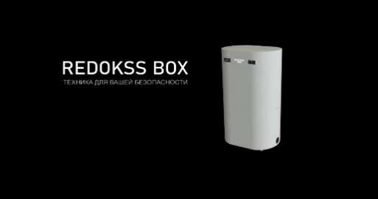
- REDOKSS BOX® (own development) - a disinfection cabinet that is incredible in the breadth of its applications. This device allows you to disinfect any thing or objects that are put into it in a few minutes.
Ozone kills all types of bacteria, viruses, fungi and protozoa. And this, unlike many antiseptics, ozone does not have a destructive and irritating effect on tissues, since the cells of a multicellular organism have an antioxidant defense system. In addition to ozone, ultraviolet lamps, which are located inside the cabinet, also have a disinfecting effect.
Ozone destroys 99% of known microorganisms: viruses incl. Covid-19, bacteria, fungi, algae, their spores, protozoan cysts, etc. There are no ozone-resistant forms of microbes. Ozone removes some odors and tastes that some people find unpleasant.
Redokss Box® - is a fully automatic device. In just a few minutes, all items placed inside the box will be disinfected from viruses and bacteria. Several modes of device robots will be available to the user suitable for the following functions:
- Removal of unpleasant odors;
- Disinfection of everyday household clothing;
- Disinfection of clothing and items after use on the street and in public places;
- Disinfection of clothing and items after use in crowded places or after possible contact with sick people with infectious or viral diseases;
- Disinfection of overalls and items (both disposable before disposal, and reusable) after use in medical or other institutions, where there is a very high probability of contact with any possible viruses, bacteria, mold, fungi.

Redokss Box® - is very wide in its field of application. It can be used like:
- Disinfecting home cabinet;
- Publicly accessible container for personal protective equipment;
- Disinfection cabinet for medical areas;
- Industrial disinfection urn for factories and enterprises;
This cabinet has a large enough internal space in order to kill germs and bacteria from a large number of objects, food or up to 10 clothes hangers in one operation.
Installation dimensions are: 1500x1000x750 mm.

- Checkpoint - Redokss COVID Defender (own development)
The company has developed a decontamination checkpoint.
This device allows you to disinfect the clothes and skin of the incoming person, to measure the body temperature and thereby prevent the penetration of diseased subjects into the premices.
The body of the checkpoint is made of fiberglass with the use of polyurethane foam, which means that the body is durable and is it is resistant to any external influences and aggressive environment.
The overall dimensions of this item are 2200x1500x1500 mm. Disinfection is performed by spraying safe mist disinfectants using fogging nozzles.
The power unit is a high-pressure plunger pump, with changeable rated, depending on the required area of disinfection and the number of people passing through the system.
The standard pump pressure is up to 90 bar.
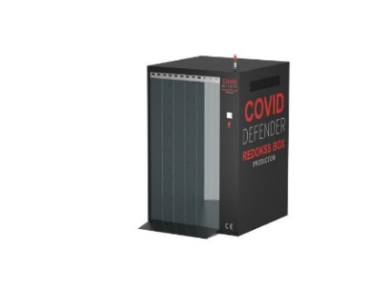
The tank for the disinfecting liquid is built into one of the walls. Its volume is - 300 liters, which allows about 7000 people to pass; working at full capacity. The tank is made of fiberglass.
The data on the amount of liquid in the tank will be displayed on the display and will signal if it is insufficient.
When the liquid in the tank runs out, the pump will automatically turn off and the sensor will signal this, after which it will be necessary to fill in the liquid through the filler neck located in the housing on the side of the outlet from the point to the required volume and resume operation with the on / off button, which will also be located on the exit sides. Spray efficiency - 4.5 kg / s.
The technology and spaywidth of the device allows it to be installed at the entrances of hypermarkets and markets, at the checkpoints of enterprises, companies and government. institutions.
Scopes of the checkpoint:
- At the entrance of markets / supermarkets;
- At the entrances / exits to private companies and enterprises;
- At the checkpoints of various government agencies;
- At the entrances of train stations and airports.
- At the entrances to educational institutions;

- Station for ozone deodorization and air disinfection NOVA CAELI® (joint development with Ukrainian scientists)
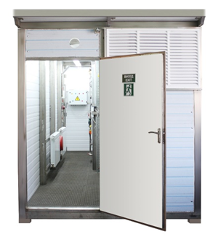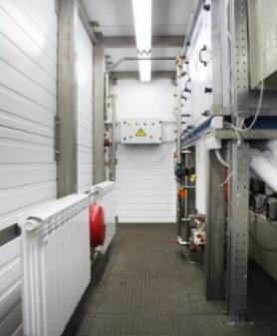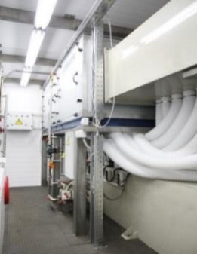
Station NOVA CAELI® (fig. 1, 2, 3) is intended for air purification from dust, aerosols, organic compounds, its deodorization and disinfection (99% destruction of viruses, bacteria, mold, fungi, etc.) using an air-ozone mixture.
The areas of application of the station are very wide, ranging from large industrial enterprises with polluted emissions, medical institutions, shopping and entertainment centers and ending with agricultural (poultry and livestock farms), industrial enterprises and enterprises of the housing and communal sector (treatment of waste water, odors, harmful emissions, etc. etc.).
At the moment, two stations are being produced for a customer from the Czech Republic, with the subsequent connection of these stations to the healthcare facility ventilation systems, institutions, shopping and entertainment centers.

Our official website: http://redokss.com.ua/ , available in the following languages: EN | DE | TR | RU | UA.
Plumbing and bathware purchase store website: https://shopredokss-san.com.ua/
Oleksandr Andriushenkov
+38 067 642 45 45

