Dear friend!

Metal-Print LTD (Dnipro) is an ultra modern manufacturer for the tin packing industry, specialising in the following services:
- Manufacturing of twist off closures
- Cutting tinplate or aluminium coils into sheets
- Lacquering and full colour printing on tinplate and aluminium sheets
Metal-Print utilises the following production equipment:
- Twist off closures production line, Rainer Naroska Engineering GmbH (Lemgo, Germany),
- Coating line, KBA-MetalPrint GmbH (Stuttgart, Germany),
- Full colour printing line, KBA-MetalPrint GmbH (Stuttgart, Germany),
- Prepress complex Ctp, AGFA (Mortsel, Belgium),
- Laboratory for coatings and inks X-Rite, IGT.
We make our Twist-off closures of the following sizes, end-usages and types:
Sizes and endusage:
82mm, 66mm & 53mm in diameter and suitable for either pasteurisation (t + 100 degrees C) or sterilisation (t + 121 degrees C). The closures are made from EFA food grade tin with double protective coating internally and externally.
Types:
RTS - standard cap with stepped profile in seal area;
RSB - standard cap with stepped profile in seal area with central vacuum button. This button, or ‘round relief’ is a visual and audible vacuum control indicator, which, upon opening for the first time, produces a click.

LACQUERING AND LITHOGRAPHY ON TINPLATE & ALUMINIUM
Metal-Print offers high quality protective lacquering and full-colour lithography on tinplate or aluminium sheets for the production of various metal packaging including cans or containers for food, beverages or chemicals, closures or fancy tins.

We use offset printing with UV inks, UV curing system and the digital computer-to-plate technology with 240 LPI printing plates. The printing quality control is governed by the X-Rite eXact measuring device to ensure the highest quality images are produced within an entire run of any print job.
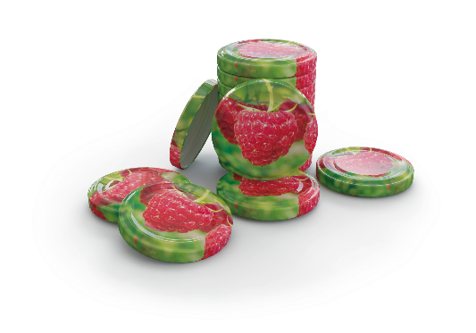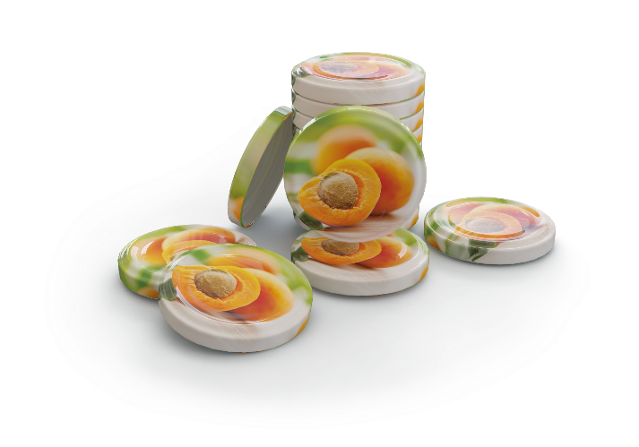
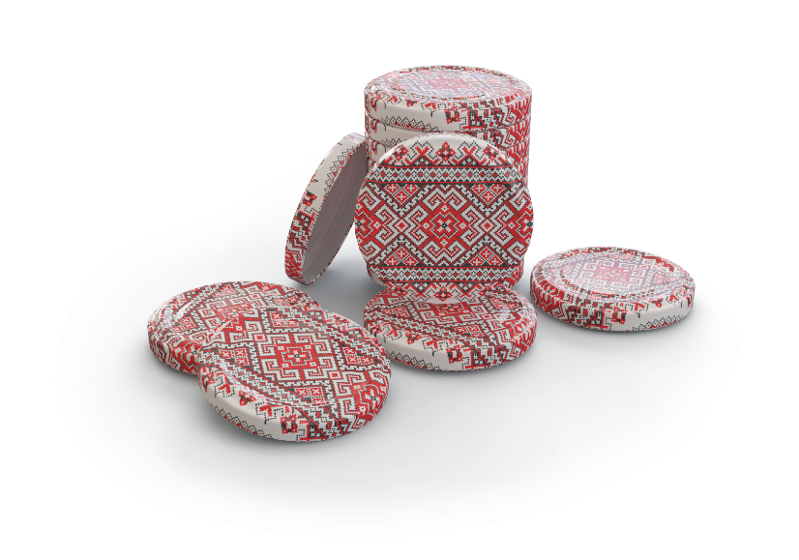
Ukraine Head Office + 380 67 565 22 71 Sergiy Kholodov
Melbourne Branch Office + 61 401 771 3 07 Sergiy Plotnikov

